Dome-shape calculation for the gradient height of concentric hydrogels.

The calculation for the dome shape can be done by the geometry in Figure S-1. Assume the dome can be fitted by a circle. Because the diameter of the PDMS dome is 12 mm that is demolded from the PMMA mold in Figure 1, the radius of the dome is 6 mm. Therefore, the curvature of the PDMS dome is H(x) = y(x) - (r- H₀).

The pink triangle is a rectangular triangle, so

$$r^{2}=6^{2}+{\left(r-H_{0}\right)}^{2}$$
$∴r= \frac{36+{H_{0}}^{2}}{2H_{0}}$

Because the dome shape is a part of a circle, so
$$x^{2}+ y^{2}= r^{2}$$
$$∴y= \sqrt{r^{2}-x^{2}}$$

The volume (V) of over injection volume in blue region in Figure S-1 can be integrated by the following equation:
$$V= \int_{r-H_{0}}^{r}{π}y^{2}dx= \int_{r-H_{0}}^{r}{π}{(\sqrt{r^{2}-x^{2}})}^{2}dx=π\left(r^{2}x-\frac{x^{3}}{3}\right)|_{r-H_{0}}^{r}=π\left(r{H_{0}}^{2}-\frac{{H_{0}}^{3}}{3}\right)$$

Bring the equations $r= \frac{36+{H_{0}}^{2}}{2H_{0}}$ into the above equation, and then the equation between volume (V) and the max height (H₀) of the dome is as below:

$$V=H_{0}(108+{H_{0}}^{2})$$

In the manuscript, the over injection volume is 40 μL. Therefore, the max height (H₀) of the dome is 0.651 mm, and r equals to 27.975 mm. Bring the values into $y= \sqrt{r^{2}-x^{2}}$ and H(x) = y(x) - (r- H₀), the relationship between H(x) and x is as below:
$$H\left(x\right)= \sqrt{{27.975}^{2}-x^{2}}-(27.975-0.651)$$

The x represents the radius of the concentric hydrogels. Therefore, bring the radius of each hydrogel into the above equation, and then H(x) can be obtained. For the height of each hydrogel under the 40-μL volume injection, it should be added extra 300 μL of the height in the flow channel (the white area in Figure S-1).
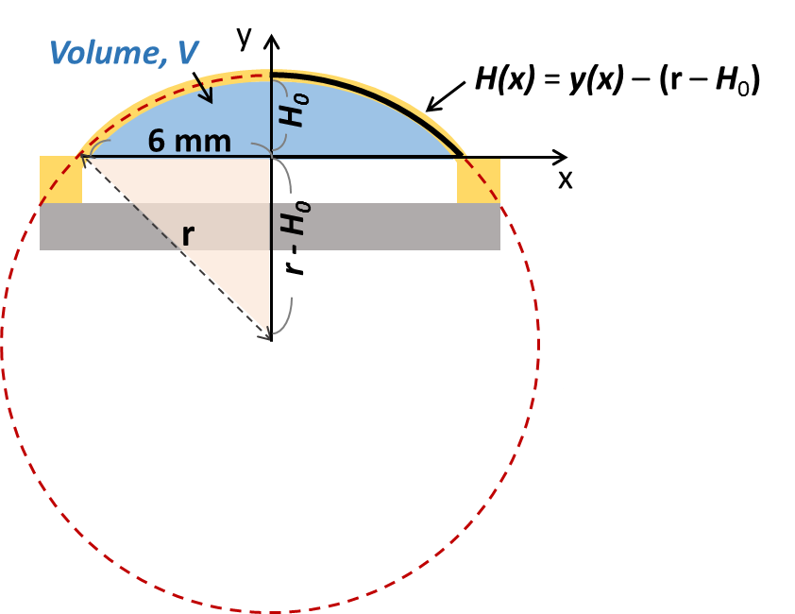
Figure S-1. Calculation of the dome-shape PDMS curvature. H(x): the convex PDMS curve; H₀: the maximum height difference of the PDMS dome before and after deformation; r: the radius of the dome; V: the over injection volume of the blue region which causes the PDMS deformation as a dome.

Table S-1. The height of each hydrogel under the dome with 40 μL volume injection. Unit: mm
 | Hydrogel line
 | 1 | 2 | 3 | 4 | 5 | 6 | 7 | 8 | 9 | 10 | 11 | 12
x | 1.1 | 1.5 | 1.9 | 2.3 | 2.7 | 3.1 | 3.5 | 3.9 | 4.3 | 4.7 | 5.1 | 5.5
H(x) | 0.629 | 0.611 | 0.586 | 0.556 | 0.520 | 0.479 | 0.431 | 0.378 | 0.319 | 0.253 | 0.182 | 0.105
Height of hydrogel | 0.929 | 0.911 | 0.886 | 0.856 | 0.820 | 0.779 | 0.731 | 0.678 | 0.619 | 0.553 | 0.482 | 0.405

