**Supplementary information**

**5.2**

The panels used for MRD and LSC are listed in Table S1. Four tubes are used MRD while tube 5 is the single LSC tube, which has 6 different antibodies in the PE channel (for details of the used antibodies see table of materials.

**Table S1. Standard MoAb panels and dilutions used in this protocol**



**Guidelines for defining LAIPs at diagnosis**

The quality of a LAIP for MRD detection depends on its:

*Specificity*

The specificity depends on the percentage of LAIP expression on **normal** cells (preferably established on normal cells at time points similar to the time points used to establish MRD during/after therapy). A high specificity can be achieved by including primitive markers (CD34, CD133 and CD117; **Figure S1**) if present on AML. In most cases LAIP expression on normal white blood cells is <0.1%.

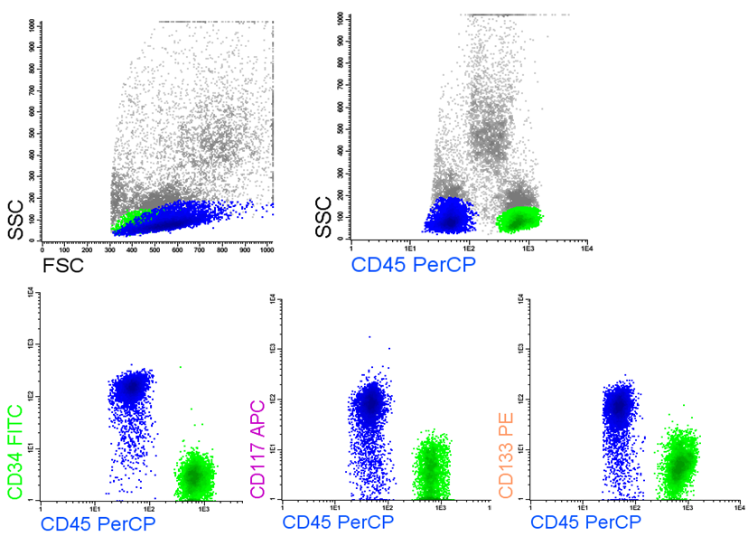

**Figure S1: Gating of the primitive markers.**

Lymphocytes (green) are used as an internal control to distinguish from myeloid populations

*Sensitivity*

The sensitivity of MRD detection depends among others on the percentage of LAIP expression on the leukemic blast population at diagnosis and the number of cells analysed. For this reason only LAIPs which are expressed >10% on the diagnosis leukemic blast population are considered, while the acquired number of cells at diagnosis are preferably 100,000 cells.

*Stability*

LAIPs may undergo phenotypic shifts. During the disease, marker expression on AML may disappear, resulting in false-negativity. Especially dim expression of markers is susceptible for changes. For an overview see Zeijlemaker et al., Cytometry B Clin Cytom 2014, 86:3-14.

Taking into account the quantity of BM material commonly available, immunophenotypic MRD detection methods enable detection of 1 MRD cell in 10,000 normal cells when using LAIPs with high specificity, high sensitivity and high stability.

***LAIPs with primitive markers***

LAIPs that include aberrant marker expression, combined with a primitive marker and a (disease specific) myeloid marker usually have a high specificity.

Primitive markers are CD34, CD133 and CD117.

Myeloid markers are CD13, CD33 and HLADR.

Markers that define a LAIP when combined with a primitive marker and a myeloid marker are:

* Expression of CD2, CD7, CD11b, CD15, CD19, CD22, CD56
* Absence of expression of CD13 (only when combined with HLADR+ or CD33+)
* Absence of expression of CD33 (only when combined with HLADR+ or CD13+)
* Absence of expression of HLADR (only when combined with CD13+ or CD33+, [in this case compared to CD34 or CD133, CD117 as primitive markers is less specific due to the promyelocytes present in a regenerating BM (use absence of CD15 to exclude the CD15 positive promyelocytes])

Likely the number and nature of the marker set will change, The most recent recommendation is from the European LeukemiaNet MRD working party, which has defined a minimal set of markers to be used for MRD, ie CD7, CD11b, CD13, CD15, CD19, CD33, CD34, CD45, CD56, CD117, HLA-DR.

In addition, for LAIPs without primitive markers (seen below) a tube is recommended that includes CD4, CD11b, CD14, CD64, apart from CD33, CD34, CD45 and HLA-DR.

**Primitive marker: use in a LAIP**

In general, a primitive marker of which the fluorescence of the conjugate exceeds the 3rd log quadrant is appropriate. The higher the fluorescence the better the discrimination between normal and leukemic cells.

In cases with equal levels of expression, use the primitive marker with the highest percentage of expression.

In cases with similar levels and percentages of marker expression, CD34 is the most reliable primitive marker: CD133 expression is often dim and CD117 may be down-regulated in peripheral blood stem cell transplantation products.

**Myeloid marker: use in a LAIP**

Preferably, use a myeloid marker which is highly expressed on the AML cells. Be alert on

* Differences in percentages expression between normal and leukemic cells: e.g. normal CD34+ cells show about >90% CD13 and CD33 expression, while leukemic cells may lack CD13 or CD33.
* Differences in levels of expression of myeloid markers between normal and leukemic cells.

However, when the LAIP includes a *lack of expression of a marker* (CD13 or CD33 or HLADR) then use a different myeloid marker, which is expressed at highest percentages on normal cells and combine with the use of a strong fluorescence label.

* The myeloid marker that is expressed should have a high fluorescence signal (beyond the 3rd log quadrant).

**Exclusion marker instead of myeloid marker**

When a primitive marker has a staining intensity that does not exceed the 3rd log quadrant, even when used with the strongest fluorescence label, it sometimes makes sense to replace the myeloid marker by an exclusion marker in order to exclude monocytes and/or granulocytes. Of course, the exclusion marker has to be absent (or present only at low percentages) on the leukemic cells.

*Exclusion markers are:* CD36 (exclusion of monocytes),CD14 (exclusion of monocytes), CD15 (exclusion of promyelocytes and more mature granulocytes).

**LAIPs without primitive markers**

The specificity of these LAIPs is less compared to LAIPs in which a primitive marker could be included. In most cases LAIPs can be defined by the absence of a myeloid marker.

Most frequently defined LAIPs without PM are:

CD15+ CD13- CD45dim CD14+

CD15- CD33+ CD45dim CD14+

CD33+ CD56++ CD45dim CD14-

HLADR- CD11b CD45dim CD14+

HLADR- CD56++ CD45dim CD33+

For defining LAIPs it can be very helpful to use the maturation patterns of the cells in normal bone marrow as shown in Figure S2.

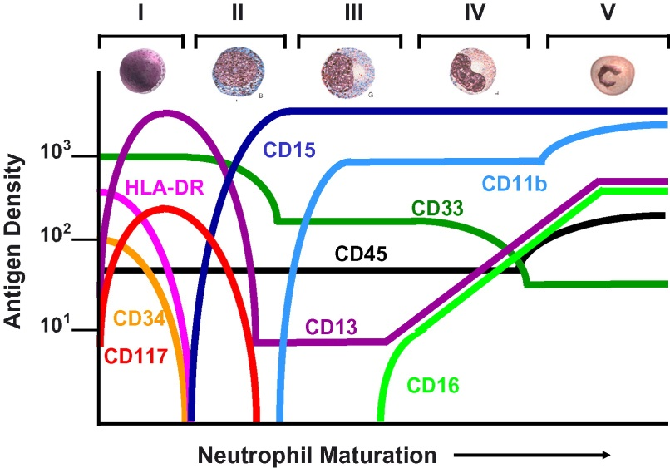

**Figure S2. Maturation patterns of CD marker expression during differentiation.** *From*: Loken MR, et al. Flow cytometry in myelodysplastic syndromes: Report from a working conference. *Leukemia Res.* 32 (1), 5-17 (2008) doi.org/10.1016/j.leukres.2007.04.020

In the ELN MRD working party a tube has been suggested for mature monocytic LAIPs that contains CD4, CD11b, CD14, CD64, apart from CD33, CD34, CD45 and HLA-DR.

Please take into account that:

1) the intensity of markers in the LAIP might have been undergone some changes compared to diagnosis material and 2) normal cells might contaminate this LAIP gate due to regeneration of the bone marrow. Therefore, the gate on the LAIP+ cells may have to be adjusted taking into account that most AML LAIP+ cells are included but with minimal contamination of normal cells. The knowledge of the antigen expression using your antibody panel in normal healthy bone marrow is very important and also the antigen expression of regenerating bone marrow.

Verify the characteristics of the LAIP+ cells by back-gating the LAIP+ cells in the density plots FSC/SSC and CD45/SSC. LAIP+ cells in these plots should be clustered and preferably similar to diagnosis. Exclude the cells with other characteristics not defined by the selected population of interest.

**Strategies for setting the cut-off for CD34+/CD38low and CD34+/CD38very low**

The setting of the CD38 negative gates are difficult to define in a clearly objective way. Still we think it is necessary to distinguish the LSC with high purity. The CD38low population may be contaminated with more progenitor like cells, while the CD34+/CD38very low are most probably predominantly LSC.

We have used 3 different approaches to set the boundaries:

*1) Spherotech beads*

From several different types of beads these were the most suitable in our protocol. Using this type of beads in the settings of our apparatus we could use the upper and lower borders of the beads as cut-off for CD34+/CD38low and CD34+/CD38very low respectively (see orange cells in Figure S3).

*2) Red fraction*

The advantage of using the red fraction is the fact that it is almost always present in the sample. The cut-offs are however relatively arbitrary. We used the upper border of the red fraction as CD38low border and the median of the red fraction as the CD38very low border (see the gray cells in Figure S3).

*3) Set borders at MFI of 103 and 102*

Based on all the experiments performed with approaches 1) and 2) we came to the conclusion that we always come up with 103 and 102 for CD38low  and CD38very low respectively. Indeed we found that with the described instrument settings these borders could be used in a multicenter study (Hanekamp et al. Br. J. Haematology, 2017, In press).



B

A

**Figure S3. LSC gating. A) CD38low border and B) CD38very low border**