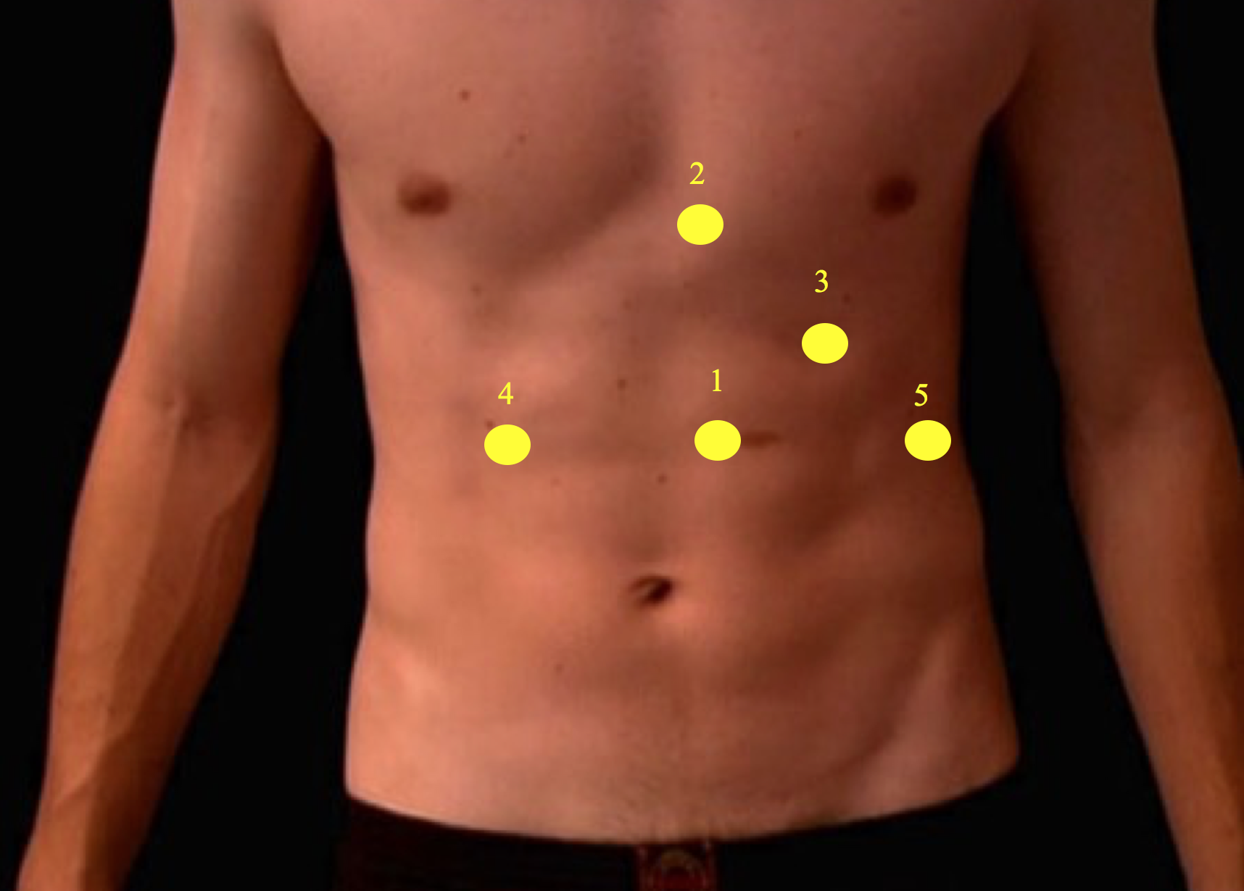

Figure
- Camera port: 10mm supra-umbilical, one hand-span from the costal margin and to the left of the midline incision.
- Nathanson liver retractor: left para-xiphoid incision.
- Working port: 5mm left mid-clavicular incision.
- Working port: 10mm right mid-clavicular incision.
- Working port: 5mm left anterior axillary incision.

